**Assignment No : 2**

**Title : The Jugad**

**1. Bathroom Mirror Hook**

**1.**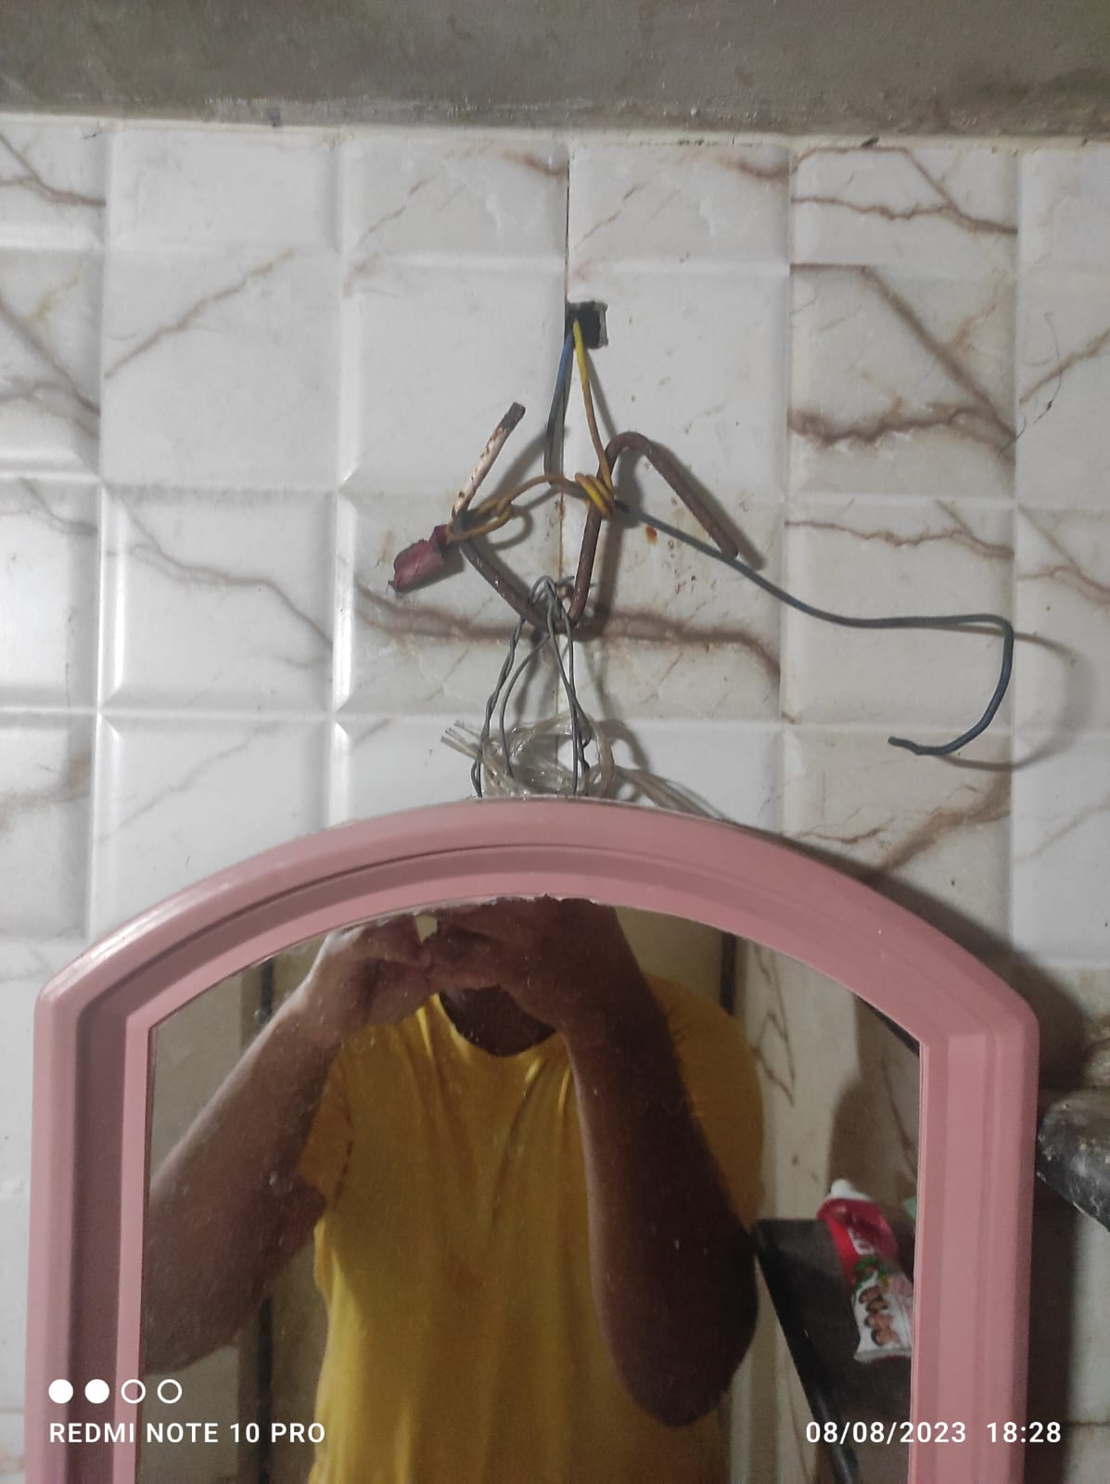

**Source –** My House Bathroom.

**Jugad –** My Bathroom is under construction/Renovation so we do not have a proper Mirror on the bathroom wall, so instead we used electric wire from one of the light outlets to hook the mirror up

**Note –** The wires are not live so there is no worries of getting shocked or electrocuted.

2. **Balcony Pipe Outlet**

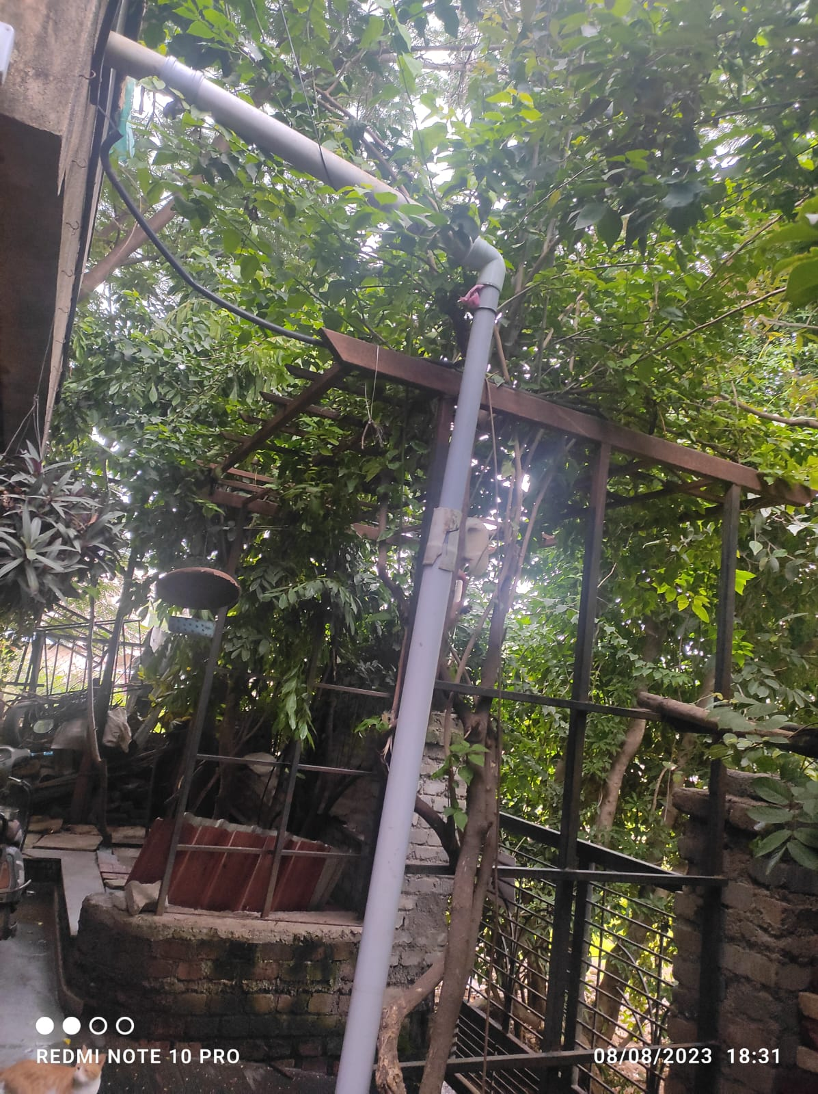

**Source –** My House Balcony.

**Jugad –** The balcony’s pipe out let was connected to PVC pipe so that the water is directed towards the planter so the plants get water. the jugad in this is that the pipes did not have proper connectors so they were connected using other broken pipes and the pipes are of different sizes.

**3.** **The Handicap Bench**

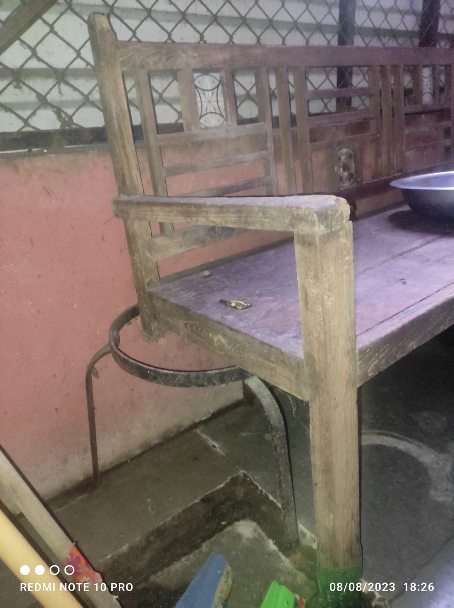

**Source –** Playground near my House.

**Jugad –** The leg of the Bench in our playground was broken so instead we found a stand which was thrown away and used it as the 4th leg of our bench.

**4. The Bag Hook**

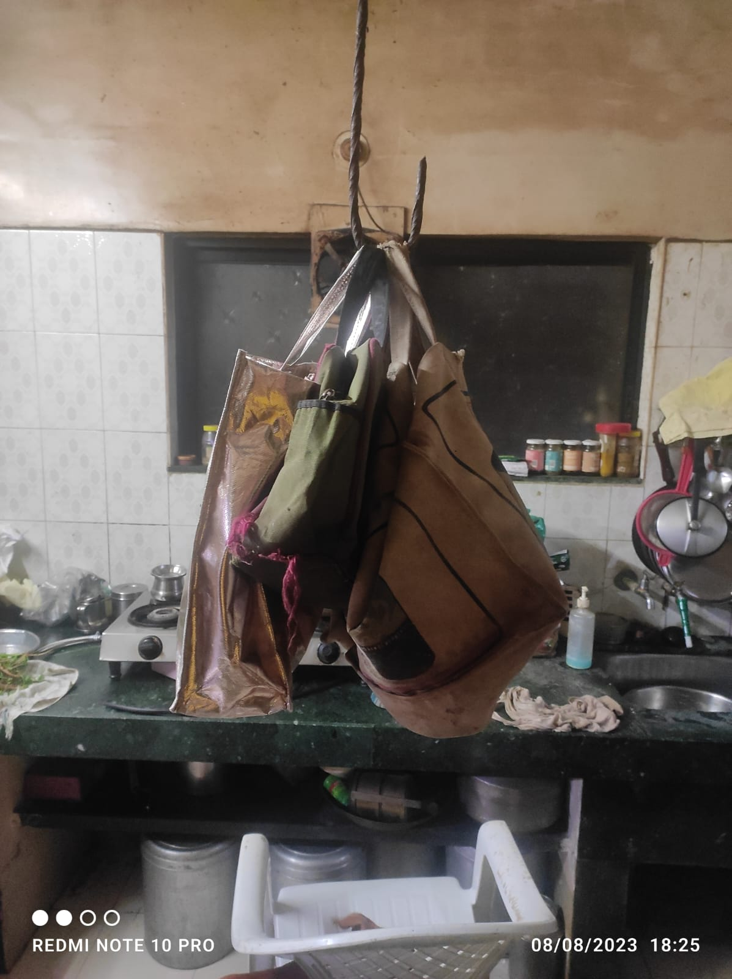

**Source –** My House Kitchen.

**Jugad –** whenever we want to go out to buy grocery its hard to find a carry bag so instead we used an iron rod hook in our kitchen which hold all the bags and it is also used to hook the filled grocery bags so we can access it quickly.